ANANNYA MISHRA

{WIPRO]

Sign LANGUAGE rECOGNITION SYSTEM uSING SPIRAL MODAL

**Why Use the Spiral Model for a Sign Language Recognition (SLR) System?**

**The Spiral Model is ideal for developing a Sign Language Recognition (SLR) System due to its iterative nature and focus on risk management. SLR systems are complex, involving advanced technologies like machine learning and real-time processing, which require flexibility and continuous improvement.**

**Key Reasons:**

1. **Risk Management:**
   * **The Spiral Model emphasizes identifying and addressing risks at every iteration. This is crucial for handling uncertainties in gesture recognition accuracy, hardware constraints, and data quality.**
2. **Iterative Development:**
   * **SLR systems benefit from iterative refinement, allowing prototypes to be evaluated, improved, and expanded in each cycle based on user feedback and performance testing.**
3. **Flexibility:**
   * **Accommodates evolving requirements, such as supporting multiple sign languages or optimizing for different environmental conditions.**
4. **Focus on Quality:**
   * **Each iteration involves thorough validation and testing, ensuring the system meets performance and usability goals before progressing.**
5. **Cost-Effectiveness:**
   * **By addressing high-risk areas early, the Spiral Model minimizes costly redesigns in later stages.**

.

**INDEX**

|  |  |  |
| --- | --- | --- |
| **Chapter No.** | **Chapter Name** | **Page No.** |
| 1  1.1  1.2  1.3  1.4 | Introduction  Aim & Objective  Background of the Project  Feature | 8  8  9  9 |
| 2  2.1  2.2  2.3  2.4 | S/W Requirement Specification  Purpose  Scope  Acronym  Overview of the Project | 10  10  10  10  11 |
| 3  3.1  3.2  3.3  3.4  3.5 | Technical Aspects  VS Code  Python  HTML  CSS and JavaScript  MySQL | 11  11  11  12  13  13 |
| 4  4.1  4.1.1    4.1.2    4.1.3    4.2  4.3  4.3.1 | System Design  Data flow Diagram  DFD for Sign Language Recognition System Level 0  DFD for Sign Language Recognition System Level 1  DFD for Sign Language Recognition System Level 2  How it works?  Database Table  User table | 14  14  15  15  16  17  18  18 |
| 5  5.1  5.1.1  5.1.2  5.1.3  5.1.4  5.2  5.2.1  5.2.2  5.2.3  5.2.4  5.2.5  5.3  5.3.1  5.3.2  5.3.3  5.3.4  5.3.5  5.3.6 | Coding and Outputs  HTML  Login  Home Page  About  How it works?  Database  Configuration Setting  Basic functionality  Additional actions  Dashboard  Test  Python  Data Collection  Import and connect data  Image recognition from import  Train model  Generate output screen  Connect Front-end and Back-end | 19  19  19  22  25  29  32  32  33  34  39  39  44  44  48  49  52  53  58 |
| 6 | Limitation and Future Scope | 58 |
| 7 | Conclusion | 60 |
| 8 | Reference and Bibliographies | 61 |

**CHAPTER-I**

**INTRODUCTION**

* 1. **Project Aims and Objectives:**

The aim of this project is to help the hearing-impaired individuals and objective is to break communication barrier between those individuals with the world.

**The project objectives are:**

* To enhance accessibility.
* To improve communication channels
* To design a user-friendly graphical user interface which suit the users
* To help them make friends
* Education Support
* To help them get socialized

**1.2.** **Background of the Project**

Sign Language Recognition system is an application which refers to a program that represents a significant advancement in assistive technology , empowering individuals with hearing impairments. So basically, they will login to the program and can use the camera as an interpreter to help them.

This model is basically made using **SPIRAL MODEL** and this show how Spiral Model works.

**1.3. Operation Management**

|  |  |
| --- | --- |
| Processor | Intel Core Processor |
| Operating system | Windows 11 |
| Memory | 8GB |
| Hard Disk Space | Minimum 3GB for Database |
| Language | HTML, CSS, JS, Python 3.10.7 ,Python script |
| IDE Tool | VScode |
| RDBMS | My-SQL |

**1.4. Features of Sing Language Recognition System Project**

**Gesture Recognition:** The program recognizes a wide range of sign language gestures, including alphabet signs, numbers, common phrases, and custom gestures.

**Real-Time Feedback:** Users receive immediate feedback through visual cues or synthesized speech, enhancing communication efficiency and accuracy.

**Customization Options:** The system allows users to customize gesture libraries, adapt recognition models to individual signing styles, and integrate new gestures seamlessly.

**Accessibility:** SLRS promotes inclusivity by providing a platform for seamless communication between the hearing impaired and hearing individuals across various digital interfaces, such as computers, mobile devices, and communication aids.

**CHAPTER-II**

**SOFTWARE REQUIREMENTS SPECIFICATION**

**2.1. Purpose**

The purpose of this document is to familiarize reader with software. Specification describes all hardware and software requirements for the project, behaviour of it and its components. SRS allows to verify the user that all the requirements are observed and implemented correctly.

**2.2. Scope**

The software will reflect all the requirements defined by the user. The Library Management System will allow to perform all necessary procedures for librarians and other users. LMS will also provide necessary services for databases such as creating, deleting, updating and searching information for students and books. The admin can generate the report about the availability of the books present in the library, number of books issued in total and student information who have borrowed the books from the library.

**2.3. Acronyms**

Python: Platform Independence

My-SQL: Structured Query Language

HTML: Website creation

CSS: Styling Website

JS: set of statements that take inputs, do some specific computation, and produce output.

Python script: To import Module.

* 1. **Overview of the Project**

The implementation of LMS with entering and updating master records like book details, student details etc. Any further transaction like book issue, book return, adding new students will automatically update the current status.

**CHAPTER-III**

**TECHNICAL ASPECTS**

**3.1. VS Code**

VS code stands for Visual Studio Code is a free source-code editor developed by Microsoft for Windows, Linex, and macOS. It includes support for debugging, embedded Git control, syntax highlighting, intelligent code completion, snippets, and code refactoring.

VS Code also has customizable features through extensions that can be downloaded from the Visual Studio Code Marketplace. It is popular among developers for its lightweight and fast performance, as well as its extensive ecosystem of extensions that enhance its functionality for various programming language such as C, C++, Java, Python, Html, CSS, JavaScripts etc

VS Code is consists of:

1. Source code editor
2. Compiler and/or an interpreter
3. Extensions
4. Debugger.
5. Terminal

**3.2. Python**

Python is a popular high-level, general-purpose programming language know for its simplicity and readability. It supports multiple programming paradigms, including procedural, object-oriented and functional programming.

The python is a high-level built in data structures, combined with dynamic typing and dynamic binding, make it very attractive for Rapid Application Development, as well as for use as a scripting or glue language to connect existing components to- gether.

Python’s simple, easy to learn syntax emphasizes readability and therefore reduce the cost of program maintenance. It supports modules and packages, which encourages program modularity and code reuse. The Python interpreter and the extensive standard library are available in source or binary form without charge for all major platforms, and can be freely distributed.

**3.3.HTML**

HTML stands for Hypertext Markup Language is the standard markup language use to create and design documents on the World Wide Web. It provides the structure and content of web pages.

* Hyper Text: HyperText simply means “Text within Text”. A text has a link within it, is a hypertext. Whenever you click on a link which brings you to a new webpage, you have clicked on a hypertext. HyperText is a way to link two or more web pages (HTML documents) with each other.
* Markup language: A markup language is a computer language that is used to apply layout and formatting conventions to a text document. Markup language makes text more interactive and dynamic. It can turn text int images, tables, links etc.
* Web Page: A web page is a document which is commonly written in HTML and translated by a web browser. A web page can be of the static or dynamic type. With the help of HTML only, we can create static web pages

HTML documents are made up of elements, which are defined by tags. Tags typically come in pairs, with an opening tag and a closing tag. For example: ‘<p>’ is a opening tag for paragraph, and ‘</p>’ is a closing tag. It elements can have attributes that provide additional information about the elements. Attributes are added to opening tag and are typically name-value pairs. For example, ‘<img src = ”imag.jpg” alt = “Image”>’ specifies an image element (‘<img>’) with ‘src’ and ‘alt’ attributes.

**3.4. CSS and JavaScript**

CSS stands for Cascading Style Sheets is a style sheet language used to describe the presentation of a document written in HTML or XML(including XML dialects such as SVG, MathML, etc.). CSS describes how elements should be rendered on screen , on paper, in speech, or on other media.

CSS selectors are patterns used to select and style elements in an HTML document. They can target elements based on their tag names, classes, IDs, attributes, and relationships with other elements. It properties are the stylistic attributes that you can apply to selected elements. Properties control things like color, size, font, spacing, and more.

JavaScript is a programming language that enables you to add interactivity and dynamic behaviour to web pages. It is commonly used in web development for things like form validation, interactive maps, content updates, and much more. It code is executed on the client’s browser, allowing for dynamic changes to the webpage without needing to reload the entire page.

JavaScript can manipulate the Document Object Model (DOM), which represents the structure of the HTML document. This allows you to dynamically change the content, structure, and style of the webpage.

**3.5. My-SQL**

**MySQL** is a freely available open-source Relational Database Management System (RDBMS) that uses Structured Query Language (**SQL**). **SQL** is the most popular language for adding, accessing and managing content in a database. It is most noted for its quick processing, proven reliability, ease and flexibility of use. MySQL is a fast, easy-to-use RDBMS being used for many small and big businesses. MySQL is developed, marketed and supported by MySQL AB, which is a Swedish company. MySQL is becoming so popular because of many good reasons −

* MySQL is released under an open-source license. So, we have nothing to pay to use it.
* MySQL is a very powerful program in its own right. It handles a large subset of the functionality of the most expensive and powerful database packages.
* MySQL uses a standard form of the well-known SQL data language.
* MySQL works on many operating systems and with many languages including PHP, PERL, C, C++, JAVA, etc.
* MySQL works very quickly and works well even with large data sets.
* MySQL is very friendly to PHP, the most appreciated language for web development.
* MySQL supports large databases, up to 50 million rows or more in a table. The default file size limit for a table is 4GB, but you can increase this (if the operating system can handle it) to a theoretical limit of 8 million terabytes (TB).
* MySQL is customizable. The open-source GPL license allows programmers to modify the MySQL software to fit their own specific environments.

**CHAPTER-IV**

**SYSTEM DESIGN**

**4.1.** **Data Flow Diagram (DFD)**

Data flow diagram (DFD) depicts the flow of information and the transformation applied when a data moves in and out from a system. The overall system is represented and described using input, processing and output in the DFD. The inputs can be:

* + **User data:** which will used for login into website.
  + **Webcam:** which will take the hand gesture from user.
  + **Human hand:** which will use for recognition of gestures.

The overall processing unit will contain the following output that a system will produce or generate:

* + After login user will connect to webcam.
  + The recognized gestures can then be translated into text language for communication

**4.1.1. DFD for Sign Language Recognition System Level 0**

To start with, let us familiarize what is Sign Language Recognition (SLR) System level 0. SLR system level 0 is also known as context diagram. It’s supposed to be an abstract view, with the mechanism represented as a single process with external parties. This DFD for library management system depicts the overall structure as a single bubble. It comes with incoming/outgoing indicators showing input and output data.

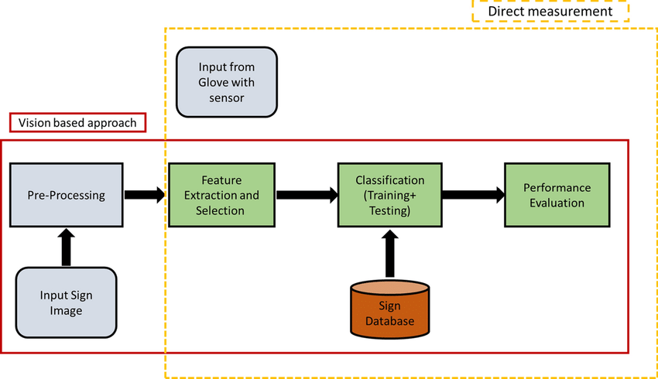

**4.1.2. DFD for Sign Language Recognition System Level 1**

Next to the context diagram is the level 1 data flow diagram. The content of system level 1 must be single process node from the context diagram is broken down into sub processes. In this level, the device must display or reveal further processing information. The following are critical procedures to complete:

* Registration of Users
* Login to home page

These procedures require information such as a User name, E-mail, passwaord. This type of data is represented by a data store.

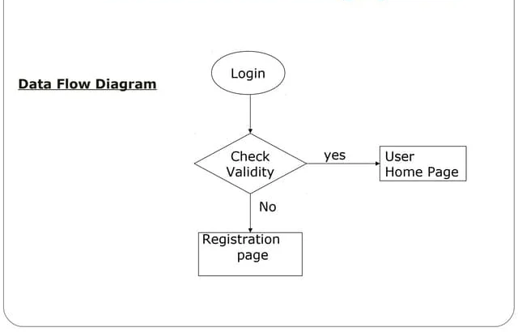

**4.1.3. DFD for Sign Language Recognition System Level 2**

After presenting the Sign Language Recognition system DFD levels 0 and 1, next to that is level 2. Here’s what you need to consider in creating data flow diagram level 2 for Sign Language Recognition system. The Level 2 DFD for Sign Language Recognition system should represent the basic modules as well as data flow between them. Since the DFD level 2 is the highest abstraction level, its Sign Language Recognition system processes must be detailed that is based on the DFD level 1. Finally, after figuring the processes given in the system, the user will now have their request being processed. In this level we will now have the ideas on where does the data inputs goes and inputs comes. Considering the dataflow levels mentioned above, we can determine well the importance of breaking the processes into more specific manner.

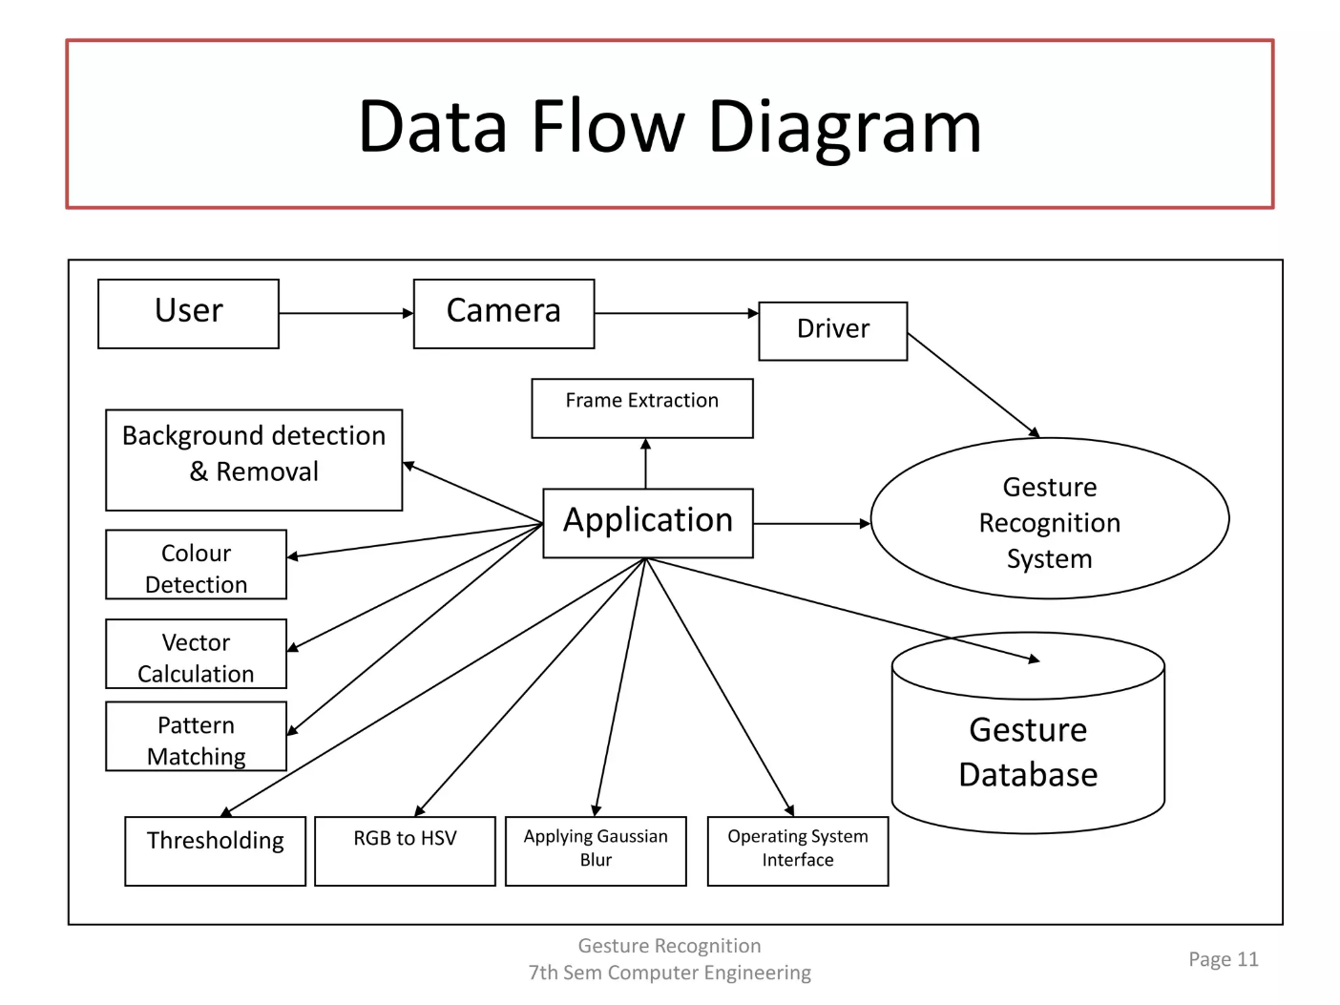

**4.2. How it work**

* Signup: If you're new to our platform, sign up for an account. Provide your details to create an account and gain access to our sign language recognition system.
* Login: If you already have an account, simply log in using your credentials. Enter your username and password to access your account dashboard.
* Start Recording: Once logged in, navigate to the recording section and click on the "Start Recording" button. This will activate your device's camera to record the actions of a specially abled person.
* Record Actions: Record the actions of the specially abled person using the camera. Ensure clear visibility of the gestures to ensure accurate recognition.
* Convert to Text: After recording, our system will process the video data and analyze the sign language gestures. Using advanced algorithms, it will convert these gestures into text format.
* Understandable Output: The converted text will be presented in a format easily understandable by a normal person. This enables seamless communication and comprehension of sign language gestures.
* Review and Share: Review the converted text for accuracy and clarity. Once satisfied, you can share the text with others to facilitate communication and understanding. 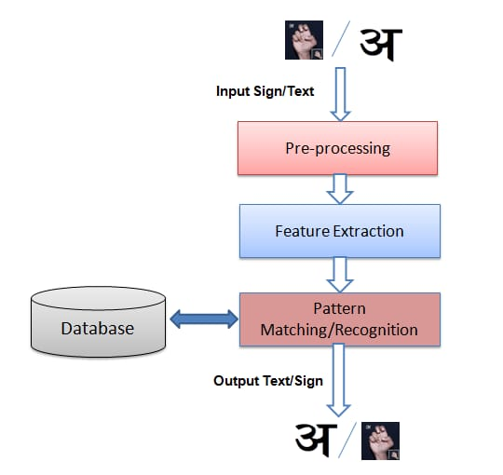

**4.3. Database Tables**

**4.3.1. User detail**

|  |  |  |
| --- | --- | --- |
| Serial no. | Int | Not Null, Primary key |
| User Name | Char | Not Null |
| Password | Char | Not Null |
| Email Id | Varchar2 | Not NUll |
| Phone No | Int | Not Null |

**CHAPTER-V**

**CODING**

**5.1. HTML:**

**5.1.1. Login:**

**Source code:**

<!DOCTYPE html>

<html lang="en">

<head>

<meta charset="UTF-8">

<meta name="viewport" content="width=device-width, initial-scale=1.0">

<title>Login</title>

<link href="https://cdn.jsdelivr.net/npm/bootstrap@5.3.0-alpha1/dist/css/bootstrap.min.css" rel="stylesheet">

<style>

body {

background-image: url("signup&login-bg.jpg");

background-size : cover;

background-color:rgba(0,0,255,0.2)

}

.container {

max-width: 400px;

margin-top: 100px;

background-color: rgba(255, 255, 255, 0.5);

padding: 20px;

border-radius: 10px;

}

</style>

</head>

<body>

<div class="container">

<h3 class="mb-3">Login</h3>

<form action="action.php" method="post">

<div class="mb-3">

<label for="a_email" class="form-label">Email address</label>

<input type="email" class="form-control" id="a_email" name="a_email" aria-describedby="emailHelp" required>

</div>

<div class="mb-3">

<label for="a_password" class="form-label">Password</label>

<input type="password" class="form-control" id="a_password" name="a_password" required>

</div>

<button type="submit" name="submit" value="Login" class="btn btn-primary">Login</button>

<a href="signup.php" class="btn btn-link">Sign Up</a>

<?php

if(isset($_POST['submit'])) {

header("Location:/sldfinal/signlamguagedetection/templates/homepage.php");

exit();

}?>

</form>

</div>

</body>

</html>

**Output:**

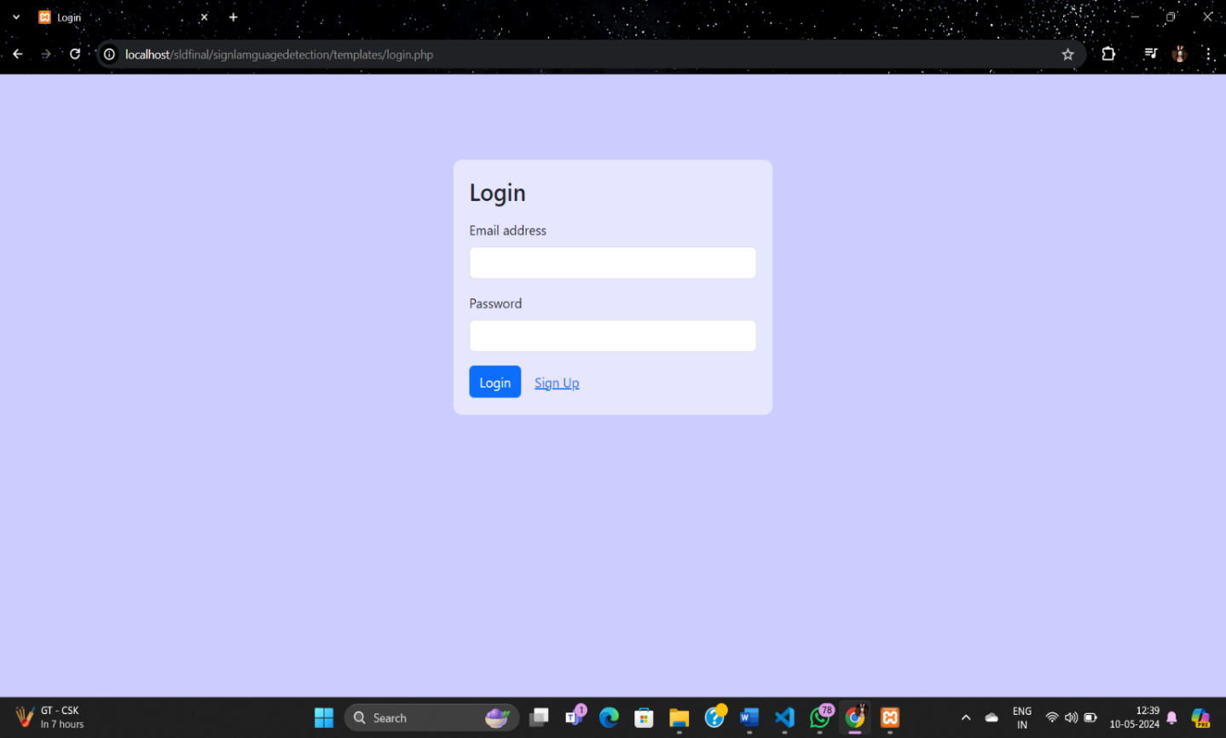

**5.1.2. Home page:**

**Source code:**

<!DOCTYPE html>

<html lang="en">

<head>

    <meta charset="UTF-8">

    <meta name="viewport" content="width=device-width, initial-scale=1.0">

    <title>Homepage</title>

    <style>

        body {

            background-image: url("backgroundimg.jpg");

            background-repeat: no-repeat;

            background-position: center top;

            background-size: cover;

            margin: 0;

            padding: 0;

            overflow: hidden;

        }

        header {

            display: flex;

            justify-content: space-between;

            align-items: center;

            padding: 20px;

            background-color: #0E4D92;

            color: #fff;

            position: relative;

        }

        .logo {

            margin-left: 120px;

        }

        .logo img {

            height: 77px;

        }

        .nav-wrapper {

            display: flex;

            align-items: center;

            font-size: 16px;

        }

        nav ul {

            list-style-type: none;

            margin: 0;

            padding: 0;

        }

        nav ul li {

            display: inline;

            margin-right: 20px;

        }

        nav ul li a {

            color: #fff;

            text-decoration: none;

        }

        nav ul li a:hover {

            border-bottom: 2px solid #fff;

        }

        .signup a {

            background-color: #fff;

            color: #333;

            padding: 10px 20px;

            border-radius: 5px;

            text-decoration: none;

        }

        .signup a:hover {

            background-color: #ccc;

        }

        .record-button {

            position: absolute;

            top: 280px;

            left: 50%;

            transform: translateX(-50%);

            background-color: #0E4D92;

            color: white;

            padding: 15px 30px;

            border-radius: 50px;

            text-decoration: none;

            font-weight: bold;

            z-index: 1;

            cursor: pointer;

        }

        .record-buttonstop{

            position: absolute;

            top: 350px;

            left: 50%;

            transform: translateX(-50%);

            background-color: #0E4D92;

            color: white;

            padding: 15px 30px;

            border-radius: 50px;

            text-decoration: none;

            font-weight: bold;

            z-index: 1;

            cursor: pointer;

        }

        .record-button:hover {

            box-shadow: 0 0 0 3px #fff, 0 0 0 6px #000;

        }

        .record-buttonstop:hover{

            box-shadow: 0 0 0 3px #fff,  0 0 0 6px #000;

        }

    </style>

</head>

<body>

    <header>

        <div class="logo">

            <img src="./logo.jpg" alt="Logo">

        </div>

        <div class="nav-wrapper">

            <nav>

                <ul>

                    <li><a href="homepage.php">Home</a></li>

                    <li><a href="About.php">About Us</a></li>

                    <li><a href="Howitworks.php">How It Works</a></li>

                </ul>

            </nav>

            <div class="signup">

                <a href="./signup.html">Sign Up</a>

            </div>

        </div>

    </header>

 <a href="http://127.0.0.1:5000/run_script" class="record-button" id="startRecording">Start Recording</a>

  <a href="http://127.0.0.1:5000/stop_script" class="record-buttonstop" id="stopRecording">Stop Recording</a>

 <script>

        document.getElementById("startRecording").addEventListener("click", function() {

            alert("Please sign up to start recording.");

        });

</script>

 </body>

 </html>

**Output:**

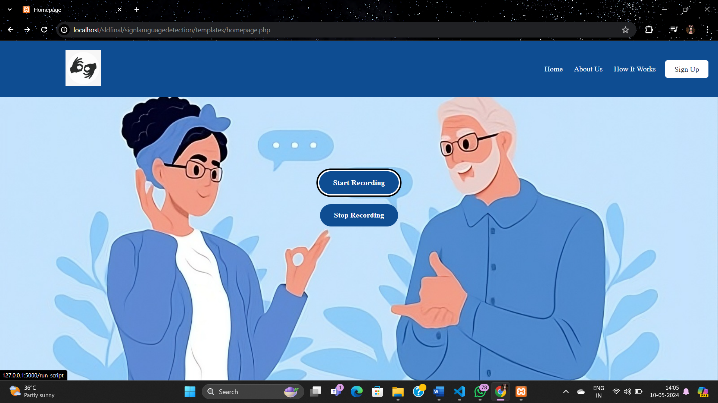

**5.1.3. About Us:**

**Source code:**

<!DOCTYPE html>

<html lang="en">

<head>

    <style>

       .content {

            display: flex;

            align-items: flex-start; */* Align content to the left */*

            padding-left: 90px;

            margin-bottom: 180px;

            color: white;

        }

        body{

            background-color: #79BAEC;

        }

        .content-text {

            flex: 1;

            padding-right: 20px;

        }

        .content p,

        .content ul,

        .content li {

            font-size: 20px;

        }

        #additionalText {

            display: none;

        }

        button{

            background-color: white ;

            border: 0px;

            color: blue;

            width: 7%;

        }

    </style>

</head>

<body>

    <div class="content">

       <div class="content-text">

        <h2>Sign Language Recognition System</h2>

        <p> Our project aims to develop a cutting-edge system that recognizes and interprets sign language gestures, enabling seamless communication for individuals with hearing impairments. Through advanced machine learning algorithms and computer vision techniques, our system can accurately interpret a wide range of sign gestures and translate them into text or spoken language in real-time.</p>

        <h3>Features:</h3>

        <ul>

            <li>Accurate recognition of a wide range of sign language gestures.</li>

            <li>Real-time translation of sign language gestures into text or spoken language.</li>

  <li>Support for multiple sign languages, including ASL (American Sign Language) and BSL (British Sign Language).</li>

<li>User-friendly interface for easy interaction and accessibility.</li>

  <li>Continuous learning and improvement through machine learning algorithms.</li>

  </ul>

<h3>Development Process:</h3>

 <ul>

<li>Requirement gathering and analysis to understand the needs of users with hearing impairments.</li>

<li>Research and development of machine learning models for sign language recognition.</li>

<li>Integration of computer vision techniques for gesture detection and interpretation.</li>

  <li>Software development for the user interface and backend systems.</li>

  <li>Testing and refinement to ensure accuracy, reliability, and accessibility.</li>

  </ul>

<div id="additionalText">

<h3>Impact:</h3>

<ul>

 <li>Empowers individuals with hearing impairments by providing them with a means of communication.</li>

  <li>Promotes inclusivity and accessibility in society by breaking down communication barriers.</li>

<li>Facilitates better integration of individuals with hearing impairments into various aspects of life, including education, employment, and social interactions.</li>

 <li>Raises awareness about the importance of accessibility and the needs of people with disabilities.</li>

          </ul>

        </div>

        <button id="learnMoreButton">Learn More</button>

    </div>

     </div>

<script>

    document.getElementById("learnMoreButton").addEventListener("click", function() {

        var additionalText = document.getElementById("additionalText");

        if (additionalText.style.display === "none") {

            additionalText.style.display = "block";

        } else {

            additionalText.style.display = "none";

        }

    });

</script>

</div>

</body>

</html>

**Output:**

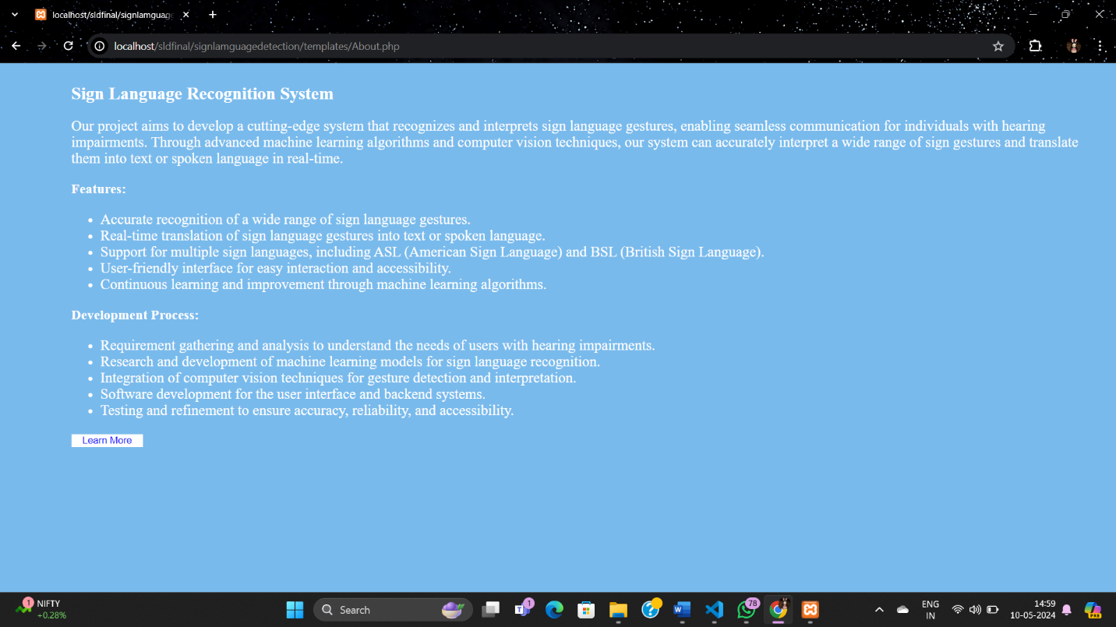

**5.1.4. How it works?**

**Source code:**

<!**DOCTYPE** html>

<html lang="en">

<head>

    <meta charset="UTF-8">

    <meta name="viewport" content="width=device-width, initial-scale=1.0">

    <title>How it Works</title>

    <style>

        body {

            font-family: Arial, sans-serif;

            color: white; */* Text color */*

            margin: 0;

            padding: 20px; */* Add padding for content spacing */*

            display: flex;

            justify-content: center;

            margin-bottom: 100px;

            margin-top: 30px;

        }

        body{

             background-color: #79BAEC;

        }

        .container {

*/* max-width: 800px; */*

            justify-content: space-between; */* Align items to left and right */*

            align-items: center; */* Center items vertically */*

            display: flex;

            flex-direction: row;

            padding-left: 60px;

            font-size: 17.5px;

        }

        .text {

            flex: 1;

            padding-right: 20px;

        }

        .image {

            flex: 1;

            text-align: right;

            padding-right: 89px;

        }

        img {

            max-width: 100%;

            height: auto;

            margin-top: 40px;

        }

    </style>

</head>

<body>

    <div class="container">

        <div class="text">

            <ul>

                <b>

                <h1>How it Works</h1>

                <li><strong>Signup:</strong> If you're new to our platform, sign up for an account. Provide your details to create an account and gain access to our sign language recognition system.</li>

                <li><strong>Login:</strong> If you already have an account, simply log in using your credentials. Enter your username and password to access your account dashboard.</li>

                <li><strong>Start Recording:</strong> Once logged in, navigate to the recording section and click on the "Start Recording" button. This will activate your device's camera to record the actions of a specially abled person.</li>

                <li><strong>Record Actions:</strong> Record the actions of the specially abled person using the camera. Ensure clear visibility of the gestures to ensure accurate recognition.</li>

                <li><strong>Convert to Text:</strong> After recording, our system will process the video data and analyze the sign language gestures. Using advanced algorithms, it will convert these gestures into text format.</li>

                <li><strong>Understandable Output:</strong> The converted text will be presented in a format easily understandable by a normal person. This enables seamless communication and comprehension of sign language gestures.</li>

                <li><strong>Review and Share:</strong> Review the converted text for accuracy and clarity. Once satisfied, you can share the text with others to facilitate communication and understanding.</li>

                </b>

            </ul>

        </div>

        <div class="image">

            <img src="howitwork.jpg" alt="Data Flow Diagram">

        </div>

    </div>

</body>

</html>

**Output:**

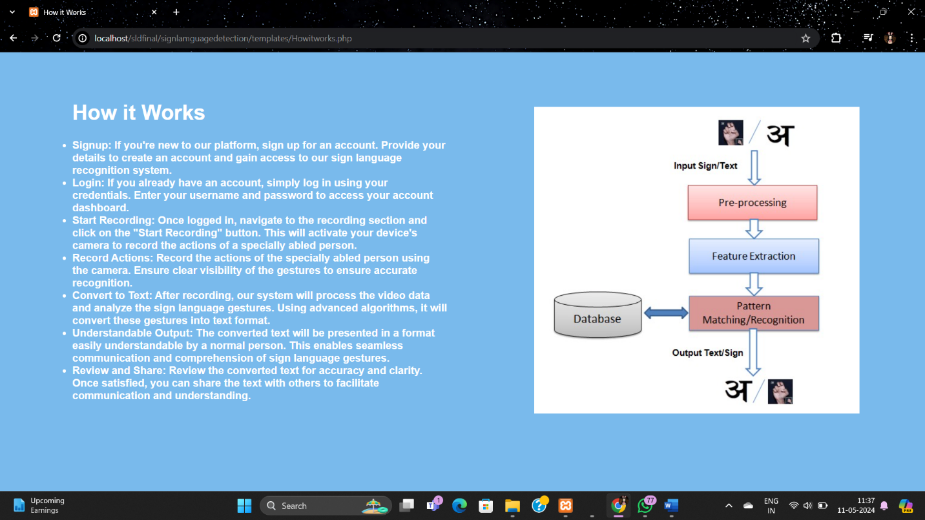

**5.2. Database:**

**5.2.1. Configuration setting:**

**Source Code:**

<?php

*//error_reporting(E_ALL | E_DEPRECATED | E_STRICT);*

error_reporting(E_ALL);

ini_set("display_errors", "0");

*/\**

*\* set default time-zone to confirm the timezone*

*\* else it will show an error that system time is not reliable*

*\* Change it as per your timezone*

*\*/*

date_default_timezone_set('Asia/Kolkata');

*/\**

*\* set maximum script execution time to overcome*

*\* timeout situations*

*\* I have set it for 5 minutes, i.e. 5 mins * 60 seconds,*

*\* But dont use unlimited or too much time as it may cause*

*\* too much server load and even breakdown*

*\*/*

set_time_limit(10 * 60);

*//amit set config*

define('CURPAGE', basename($_SERVER['PHP_SELF'])); *// basename($_SERVER['PHP_SELF']); /* Returns The Current PHP File Name */*

define('QSTRGET', urldecode($_SERVER['QUERY_STRING'])); *//   echo urldecode($_SERVER['QUERY_STRING']);*

define('SESSVAR', 'Office_manage'); *//   echo urldecode($_SERVER['QUERY_STRING']);*

define('DESCRIPTION', 'Office_manage');

define('AUTHOR', 'Office_manage');

$base = "signlanguage";

$server = "localhost";

$user = "root";

$pass = "";

*//Open a new connection to the MySQL server*

$db = new mysqli($server, $user, $pass, $base);

*//Output any connection error*

if ($db->connect_error) {

*// die('Error : (' . $db->connect_errno . ') ' . $db->connect_error);*

  header("Location:404.php");

}

**5.2.2. Basic functionalities:**

**Source Code:**

<?php

include 'config.php';

$data = $db->query("SELECT * FROM `setting`");

header("Location:signup.php");

while($value = $data->fetch_object()){

define($value->name,$value->value);

}

?>

**5.2.3. Additional actions:**

**Source Code:**

<?php

session_start();

require_once 'config.php';

require_once 'basic.php';

function getUserIpAddr(){

    if(!empty($_SERVER['HTTP_CLIENT_IP'])){

*//ip from share internet*

        $ip = $_SERVER['HTTP_CLIENT_IP'];

    }elseif(!empty($_SERVER['HTTP_X_FORWARDED_FOR'])){

*//ip pass from proxy*

        $ip = $_SERVER['HTTP_X_FORWARDED_FOR'];

    }else{

        $ip = $_SERVER['REMOTE_ADDR'];

    }

    return $ip;

}

 function getBrowser()

 {

   $user_agent = $_SERVER['HTTP_USER_AGENT'];

   $browser = "N/A";

   $browsers = [

     '/msie/i' => 'Internet explorer',

     '/firefox/i' => 'Firefox',

     '/safari/i' => 'Safari',

     '/chrome/i' => 'Chrome',

     '/edge/i' => 'Edge',

     '/opera/i' => 'Opera',

     '/mobile/i' => 'Mobile browser',

   ];

   foreach ($browsers as $regex => $value) {

     if (preg_match($regex, $user_agent)) {

       $browser = $value;

     }

   }

   return $browser;

 }

    $currentdatetime = date('d-m-Y H:i:s');

$action = $_REQUEST['submit'];

switch ($action) {

  case 'Login':

    $a_email = mysqli_real_escape_string($db, $_REQUEST['a_email']);

    $password = mysqli_real_escape_string($db, $_REQUEST['a_password']);

    $a_password = md5($password);

*//get total number of records*

    $results = $db->query("SELECT * FROM `admin` WHERE a_email='$a_email' AND a_password='$a_password' AND a_status = '1'");

    if ($results->num_rows > 0) {

      $ip = getUserIpAddr();

      $browser = getBrowser();

      $session = session_id();

      $value = $db->query("SELECT a_id, a_email, a_usertype, a_pagepermission , a_type  FROM `admin` WHERE a_email='$a_email'");

      $row = $value->fetch_object();

      $a_id = $row->a_id;

      $db->query("INSERT INTO `login_history`(`lh_id`, `a_id`, `ip_address`, `browser`, `login_time`, `session`, `sts`, `date`) VALUES (NULL,'$a_id','$ip','$browser','$currentdatetime','$session','0','$currentdatetime')");

      $db->query("UPDATE `admin` SET active = 1 WHERE a_email='$a_email'");

*//MySqli Select Query*

      session_regenerate_id();

      $a_id = session_id();

      $_SESSION[SESSVAR] = $a_id;

      $_SESSION['a_id'] = $row->a_id;

      $_SESSION['a_name'] = $row->a_name;

      $_SESSION['a_email'] = $row->a_email;

      $_SESSION['a_usertype'] = $row->a_usertype;

      $_SESSION['a_pagepermission'] = $row->a_pagepermission;

      $_SESSION['a_type'] = $row->a_type;

      if ($row->a_type == 2) {

        $_SESSION['logintype'] = 'Admin'; *// set user type*

        header("Location:dashboard?msg=" . md5('9') . "");

      }elseif($row->a_type == 3){

        $_SESSION['logintype'] = 'Staf'; *// set user type*

        header("Location:../staf/dashboard?msg=" . md5('9') . "");

      }elseif($row->a_type == 4){

        $_SESSION['logintype'] = 'Client'; *// set user type*

        header("Location:../client/dashboard?msg=" . md5('9') . "");

      }

    }else{

              $_SESSION['errormsg'] = 'Email or password does not match.';

              $_SESSION['errorValue'] = 'warning';

              header("Location:/sldfinal/signlamguagedetection/templates/homepage.php");

      }

    break;

  case 'logout':

    $a_id = $_SESSION['a_id'];

    $db->query("UPDATE `admin` SET active = 0 WHERE a_id = '$a_id'");

    $db->query("UPDATE `login_history` SET sts = 0 , logout_time = '$currentdatetime' WHERE a_id = '$a_id' AND logout_time = ''");

    unset($_SESSION[SESSVAR]);

    unset($_SESSION['logintype']); *// set user type*

    unset($_SESSION['a_id']);

    unset($_SESSION['a_email']);

    unset($_SESSION['a_usertype']);

    unset($_SESSION['a_pagepermission']);

  $_SESSION['msg'] = md5('1');

  $_SESSION['errormsg'] = 'Thank you for log out.';

    $_SESSION['errorValue'] = 'success';

    header("Location:../index?msg=" . md5('logout') . "");

    exit();

    break;

  case 'updatesetting':

    $data = $db->query("SELECT * FROM `setting`");

    while ($value = $data->fetch_object()) {

      $name = $value->name;

      if ($name == 'logo') {

      }else{

      $s_id = $value->s_id;

      $value = $_POST[$value->name];

      $db->query("UPDATE `setting` SET value = '$value' WHERE s_id = $s_id");

      }

    }

*// photoupload*

            $logo = $_FILES['logo']['name'];

             if ($logo == '') {

             }else {

                $expbanner=explode('.',$logo);

                $bannerexptype=$expbanner[1];

                $allowedTypes = array(IMAGETYPE_PNG, IMAGETYPE_JPEG, IMAGETYPE_GIF);

                $detectedType = exif_imagetype($_FILES['logo']['tmp_name']);

                    if(!in_array($detectedType, $allowedTypes)) {

                    echo 'Not Match';

                    die();

                    }else{

                        $date = date('m/d/Yh:i:sa', time());

                        $rand=rand(10000,99999);

                        $encname='img-'.$rand;

                        $bannername=$encname.'.'.$bannerexptype;

                        $bannerpath="../upload/".$bannername;

                        $bannername = website_name.'/upload/'.$bannername;

                        move_uploaded_file($_FILES["logo"]["tmp_name"],$bannerpath);

                        $db->query("UPDATE `setting` SET value = '$bannername' WHERE s_id = '3'");

                    }

                }

    $_SESSION['errormsg'] = 'Setting Update Success.';

    $_SESSION['errorValue'] = 'success';

    header("Location:../admin/setting?msg=" . md5('setting') . "");

    break;

case 'sign_up':

    $signupName = mysqli_real_escape_string($db, $_REQUEST['signupName']);

    $signupEmail = mysqli_real_escape_string($db, $_REQUEST['signupEmail']);

    $signupPassword = mysqli_real_escape_string($db, $_REQUEST['signupPassword']);

    $a_password = md5($signupPassword);

    $results = $db->query("SELECT * FROM `admin` WHERE a_email='$signupEmail'");

    if($results->num_rows == 0){

    $db->query("INSERT INTO `admin`(`a_email`,`a_password`,`a_vpwd`,`a_name`,`a_status`,`a_date`)

                            VALUES ('$signupEmail',' $a_password','$signupPassword ',' $signupName',1,'$create_at') ");

        header("Location:login.php");

    }else{

        echo '<script>alert("E-Mail already Registered")</script>';

    }

    break;

  default:

    $_SESSION['errormsg'] = 'Invalid page access.';

    $_SESSION['errorValue'] = 'danger';

    header("Location: ../404?msg=" . md5('11') . "");

}

**5.2.4. Dashboard:**

**Source Code:**

<!DOCTYPE html>

<html lang="en">

<head>

  <meta charset="UTF-8">

  <meta name="viewport" content="width=device-width, initial-scale=1.0">

  <title>Sign Up</title>

  <link href="https://cdn.jsdelivr.net/npm/bootstrap@5.3.0-alpha1/dist/css/bootstrap.min.css" rel="stylesheet">

  <style>

    body {

      background-color: #f8f9fa;

    }

    .container {

      max-width: 400px;

      margin-top: 100px;

    }

  </style>

</head>

<body>

  <div class="container">

  </div>

</body>

</html>

**5.2.5. Test:**

**Source Code:**

SET SQL_MODE = "NO_AUTO_VALUE_ON_ZERO";

START TRANSACTION;

SET time_zone = "+00:00";

DROP TABLE IF EXISTS `admin`;

CREATE TABLE IF NOT EXISTS `admin` (

  `a_id` int NOT NULL AUTO_INCREMENT,

  `a_type` int NOT NULL COMMENT '1 = admin\r\n2 = frinchase\r\n3= subfrnchaise\r\n4= user',

  `a_type_name` varchar(255) NOT NULL,

  `a_code` varchar(100) NOT NULL,

  `a_email` varchar(100) NOT NULL,

  `a_password` varchar(255) NOT NULL,

  `a_vpwd` varchar(100) NOT NULL,

  `a_name` varchar(100) NOT NULL,

  `a_desig` varchar(100) NOT NULL,

  `a_phone` varchar(15) NOT NULL,

  `a_address` tinytext NOT NULL,

  `a_company` tinytext NOT NULL,

  `a_usertype` varchar(10) NOT NULL COMMENT 'For User Privilege 1 for Admin',

  `a_status` varchar(2) NOT NULL COMMENT '1 Approve/ 2 Not Approve',

  `a_pagepermission` varchar(100) NOT NULL,

  `a_sms` varchar(20) NOT NULL,

  `img1` varchar(200) NOT NULL,

  `active` int NOT NULL,

  `a_state` varchar(255) DEFAULT NULL,

  `a_pincode` varchar(255) DEFAULT NULL,

  `user_id` varchar(255) DEFAULT NULL,

  `a_franchise` varchar(255) DEFAULT NULL,

  `a_fr_userid` varchar(255) DEFAULT NULL,

  `a_sub_fran` varchar(255) DEFAULT NULL,

  `a_sub_fran_id` varchar(255) DEFAULT NULL,

  `a_date` datetime NOT NULL DEFAULT '1970-01-01 00:00:01',

  PRIMARY KEY (`a_id`)

) ENGINE=InnoDB AUTO_INCREMENT=17 DEFAULT CHARSET=latin1;

INSERT INTO `admin` (`a_id`, `a_type`, `a_type_name`, `a_code`, `a_email`, `a_password`, `a_vpwd`, `a_name`, `a_desig`, `a_phone`, `a_address`, `a_company`, `a_usertype`, `a_status`, `a_pagepermission`, `a_sms`, `img1`, `active`, `a_state`, `a_pincode`, `user_id`, `a_franchise`, `a_fr_userid`, `a_sub_fran`, `a_sub_fran_id`, `a_date`) VALUES

(1, 1, '', '1', 'altabraja4@gmail.com', 'e10adc3949ba59abbe56e057f20f883e', '123456', 'Admin', '', '987456321', '', 'Admin', '1', '1', '1,1.1,1.2,1.3', '', 'uploads/7c434f192512fe71114f627a04bb1361.png', 1, NULL, NULL, NULL, NULL, NULL, NULL, NULL, '2018-07-04 00:00:00'),

(11, 2, '', '', 'aliya@gmail.com', 'e10adc3949ba59abbe56e057f20f883e', '123456', 'Aliya Ali', '', '7894946474', 'RKL', 'alhaya', '', '', '', '', '', 0, 'Odisha', '768201', 'SWF1234', NULL, NULL, NULL, NULL, '2023-09-15 17:21:22'),

(12, 3, '', '', 'reshma@gmail.com', 'e3cb970693574ea75d091a6049f8a3ff', 'aliya', 'Reshma Parveen', '', '9060987878', 'KIL', 'KIana', '', '', '', '', '', 0, 'Odisha', '768201', 'SWSF7772', '11', 'SWF1234', NULL, NULL, '2023-09-15 18:04:53'),

(15, 4, '', '', 'admin@utkalfriendsfairdealings.com', 'a32e73fc28e33323978f72722554dddd', 'ijiji', 'oghsp0UnQr', '', '8989898989', 'nA5QtcBdO8', 'zaopnjjNLy', '', '', '', '', '', 0, 'Odisha', '675250', 'SWSFU1671', '11', 'SWF1234', 'SWSF7772', '12', '2023-09-15 18:39:38'),

(16, 0, '', '', 'spa@hotmail.com', ' e10adc3949ba59abbe56e057f20f883e', '123456 ', ' Enjoy', '', '', '', '', '', '1', '', '', '', 0, NULL, NULL, NULL, NULL, NULL, NULL, NULL, '0000-00-00 00:00:00');

DROP TABLE IF EXISTS `feed`;

CREATE TABLE IF NOT EXISTS `feed` (

  `id` int NOT NULL AUTO_INCREMENT,

  `name` varchar(255) COLLATE utf8mb4_general_ci NOT NULL,

  `photo` varchar(255) COLLATE utf8mb4_general_ci NOT NULL,

  `create_at` timestamp NOT NULL,

  PRIMARY KEY (`id`)

) ENGINE=MyISAM AUTO_INCREMENT=34 DEFAULT CHARSET=utf8mb4 COLLATE=utf8mb4_general_ci;

INSERT INTO `feed` (`id`, `name`, `photo`, `create_at`) VALUES

(1, 'admin', '', '0000-00-00 00:00:00'),

(2, 'admin', '', '0000-00-00 00:00:00'),

(3, 'admin', '', '0000-00-00 00:00:00'),

(4, 'admin', '', '0000-00-00 00:00:00'),

(5, 'admin', '', '0000-00-00 00:00:00'),

(6, 'Enjoy Kumawat', '', '0000-00-00 00:00:00'),

(7, 'Enjoy Kumawat', '', '0000-00-00 00:00:00'),

(8, 'Enjoy Kumawat', '', '0000-00-00 00:00:00'),

(9, 'Test2', '', '0000-00-00 00:00:00'),

(10, 'Test2', '', '0000-00-00 00:00:00'),

(11, 'Test2', '', '0000-00-00 00:00:00'),

(12, 'Test2', '', '0000-00-00 00:00:00'),

(13, 'Test2', '', '0000-00-00 00:00:00'),

(14, 'Deepak Dudi', '', '0000-00-00 00:00:00'),

(15, 'Deepak Dudi', '', '0000-00-00 00:00:00'),

(16, 'Deepak Dudi', '', '0000-00-00 00:00:00'),

(17, 'Deepak Dudi', '', '0000-00-00 00:00:00'),

(18, 'Deepak Dudi', '', '0000-00-00 00:00:00'),

(19, 'Deepak Dudi', '', '0000-00-00 00:00:00'),

(20, 'Deepak Dudi', '', '0000-00-00 00:00:00'),

(21, 'admin', '', '0000-00-00 00:00:00'),

(22, 'admin', '', '0000-00-00 00:00:00'),

(23, 'admin', '', '0000-00-00 00:00:00'),

(24, 'admin', '', '0000-00-00 00:00:00'),

(25, 'admin', '', '0000-00-00 00:00:00'),

(26, 'admin', '', '0000-00-00 00:00:00'),

(27, 'admin', '', '0000-00-00 00:00:00'),

(28, 'admin', '', '0000-00-00 00:00:00'),

(29, 'admin', 'Enjoy71.jpg', '0000-00-00 00:00:00'),

(30, 'admin', 'Enjoy52.jpg', '0000-00-00 00:00:00'),

(31, 'main', 'Enjoy11.jpg', '0000-00-00 00:00:00'),

(32, 'admin', 'kaliya80.jpg', '0000-00-00 00:00:00'),

(33, 'Ankur Balwada', '', '0000-00-00 00:00:00');

DROP TABLE IF EXISTS `setting`;

CREATE TABLE IF NOT EXISTS `setting` (

  `s_id` int NOT NULL AUTO_INCREMENT,

  `name` varchar(255) NOT NULL,

  `value` longtext NOT NULL,

  `sts` int NOT NULL,

  `date` datetime NOT NULL DEFAULT CURRENT_TIMESTAMP,

  PRIMARY KEY (`s_id`)

) ENGINE=InnoDB AUTO_INCREMENT=12 DEFAULT CHARSET=latin1;*-*

INSERT INTO `setting` (`s_id`, `name`, `value`, `sts`, `date`) VALUES

(1, 'website_name', 'http://localhost/mlm-admin', 1, '2022-12-21 16:15:55'),

(2, 'business_name', 'office_manage', 0, '2022-12-21 16:16:54'),

(3, 'logo', 'http://localhost/product/office_manage/upload/img-78695.png', 0, '2022-12-21 16:17:52'),

(4, 'invoice_pre', 'ift', 0, '2022-12-21 16:18:37'),

(5, 'invoice_template', '6', 0, '2022-12-21 16:27:15'),

(6, 'invoice_colour', '#36565e', 0, '2022-12-24 21:12:39'),

(7, 'termandcondition', '', 0, '2022-12-24 21:12:39'),

(8, 'payment_details', '<p><strong>Account Name :</strong>&nbsp;Altab Raja</p>\r\n\r\n<p><strong>Account No :</strong>&nbsp;33120814769</p>\r\n\r\n<p><strong>IFC Code :</strong>&nbsp;SBIN0007001</p>\r\n\r\n<p><strong>UPI Id :</strong>&nbsp;7894947464@ybl</p>\r\n', 0, '2022-12-24 22:25:20'),

(9, 'sale_email', 'sales@ifotechsys.com', 0, '2022-12-31 15:02:50'),

(10, 'support_email', 'support@ifotechsys.com', 0, '2022-12-31 15:02:50'),

(11, 'business_email', 'info@ifotechsys.com', 0, '2022-12-31 15:02:50');

COMMIT;

**Output:**

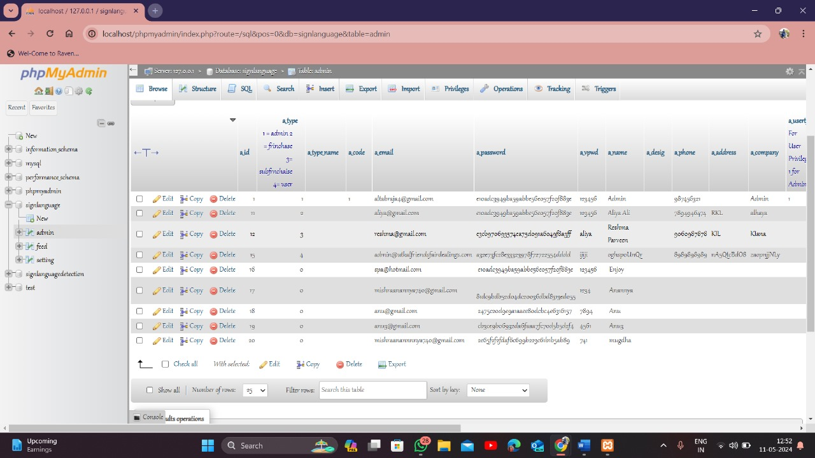

**5.3. Python:**

**5.3.1. Data collection:**

**Source Code:**

import os

import cv2

cap=cv2.VideoCapture(0)

directory='image/'

while True:

    _,frame=cap.read()

    count = {

             'a': len(os.listdir(directory+"/A")),

             'b': len(os.listdir(directory+"/B")),

             'c': len(os.listdir(directory+"/C")),

             'd': len(os.listdir(directory+"/D")),

             }

    cv2.putText(frame, "a : "+str(count['a']), (10, 100), cv2.FONT_HERSHEY_PLAIN, 1, (0,255,255), 1)

    cv2.putText(frame, "b : "+str(count['b']), (10, 110), cv2.FONT_HERSHEY_PLAIN, 1, (0,255,255), 1)

    cv2.putText(frame, "c : "+str(count['c']), (10, 120), cv2.FONT_HERSHEY_PLAIN, 1, (0,255,255), 1)

    cv2.putText(frame, "d : "+str(count['d']), (10, 130), cv2.FONT_HERSHEY_PLAIN, 1, (0,255,255), 1)

*# cv2.putText(frame, "e : "+str(count['e']), (10, 140), cv2.FONT_HERSHEY_PLAIN, 1, (0,255,255), 1)*

*# cv2.putText(frame, "f : "+str(count['f']), (10, 150), cv2.FONT_HERSHEY_PLAIN, 1, (0,255,255), 1)*

*# cv2.putText(frame, "g : "+str(count['g']), (10, 160), cv2.FONT_HERSHEY_PLAIN, 1, (0,255,255), 1)*

*# cv2.putText(frame, "h : "+str(count['h']), (10, 170), cv2.FONT_HERSHEY_PLAIN, 1, (0,255,255), 1)*

*# cv2.putText(frame, "i : "+str(count['i']), (10, 180), cv2.FONT_HERSHEY_PLAIN, 1, (0,255,255), 1)*

*# cv2.putText(frame, "k : "+str(count['k']), (10, 190), cv2.FONT_HERSHEY_PLAIN, 1, (0,255,255), 1)*

*# cv2.putText(frame, "l : "+str(count['l']), (10, 200), cv2.FONT_HERSHEY_PLAIN, 1, (0,255,255), 1)*

*# cv2.putText(frame, "m : "+str(count['m']), (10, 210), cv2.FONT_HERSHEY_PLAIN, 1, (0,255,255), 1)*

*# cv2.putText(frame, "n : "+str(count['n']), (10, 220), cv2.FONT_HERSHEY_PLAIN, 1, (0,255,255), 1)*

*# cv2.putText(frame, "o : "+str(count['o']), (10, 230), cv2.FONT_HERSHEY_PLAIN, 1, (0,255,255), 1)*

*# cv2.putText(frame, "p : "+str(count['p']), (10, 240), cv2.FONT_HERSHEY_PLAIN, 1, (0,255,255), 1)*

*# cv2.putText(frame, "q : "+str(count['q']), (10, 250), cv2.FONT_HERSHEY_PLAIN, 1, (0,255,255), 1)*

*# cv2.putText(frame, "r : "+str(count['r']), (10, 260), cv2.FONT_HERSHEY_PLAIN, 1, (0,255,255), 1)*

*# cv2.putText(frame, "s : "+str(count['s']), (10, 270), cv2.FONT_HERSHEY_PLAIN, 1, (0,255,255), 1)*

*# cv2.putText(frame, "t : "+str(count['t']), (10, 280), cv2.FONT_HERSHEY_PLAIN, 1, (0,255,255), 1)*

*# cv2.putText(frame, "u : "+str(count['u']), (10, 290), cv2.FONT_HERSHEY_PLAIN, 1, (0,255,255), 1)*

*# cv2.putText(frame, "v : "+str(count['v']), (10, 300), cv2.FONT_HERSHEY_PLAIN, 1, (0,255,255), 1)*

*# cv2.putText(frame, "w : "+str(count['w']), (10, 310), cv2.FONT_HERSHEY_PLAIN, 1, (0,255,255), 1)*

*# cv2.putText(frame, "x : "+str(count['x']), (10, 320), cv2.FONT_HERSHEY_PLAIN, 1, (0,255,255), 1)*

*# cv2.putText(frame, "y : "+str(count['y']), (10, 330), cv2.FONT_HERSHEY_PLAIN, 1, (0,255,255), 1)*

*# cv2.putText(frame, "z : "+str(count['z']), (10, 340), cv2.FONT_HERSHEY_PLAIN, 1, (0,255,255), 1)*

    row = frame.shape[1]

    col = frame.shape[0]

    cv2.rectangle(frame,(0,40),(300,400),(255,255,255),2)

    cv2.imshow("data",frame)

    cv2.imshow("ROI",frame[40:400,0:300])

    frame=frame[40:400,0:300]

    interrupt = cv2.waitKey(10)

    if interrupt & 0xFF == ord('a'):

        cv2.imwrite(directory+'A/'+str(count['a'])+'.png',frame)

    if interrupt & 0xFF == ord('b'):

        cv2.imwrite(directory+'B/'+str(count['b'])+'.png',frame)

    if interrupt & 0xFF == ord('c'):

        cv2.imwrite(directory+'C/'+str(count['c'])+'.png',frame)

    if interrupt & 0xFF == ord('d'):

        cv2.imwrite(directory+'D/'+str(count['d'])+'.png',frame)

cap.release()

cv2.destroyAllWindows()

**Output:**

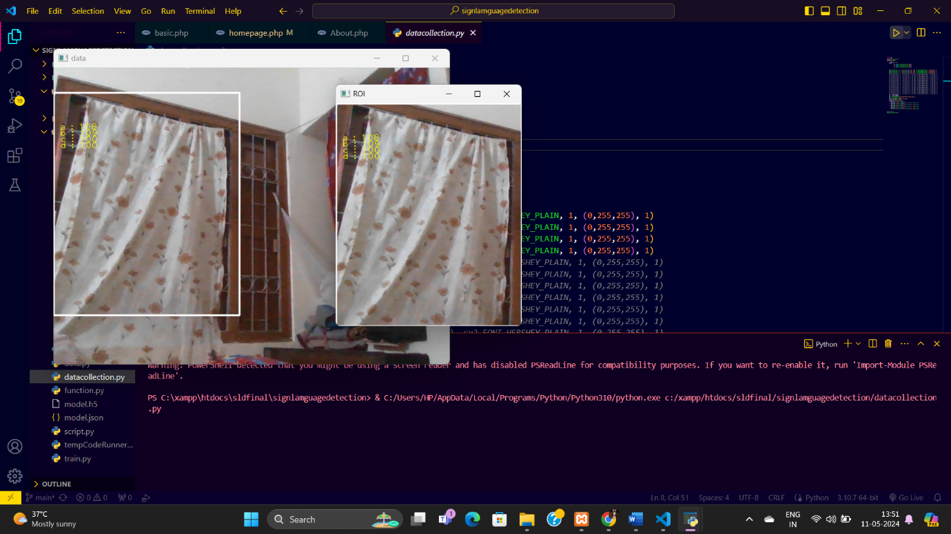

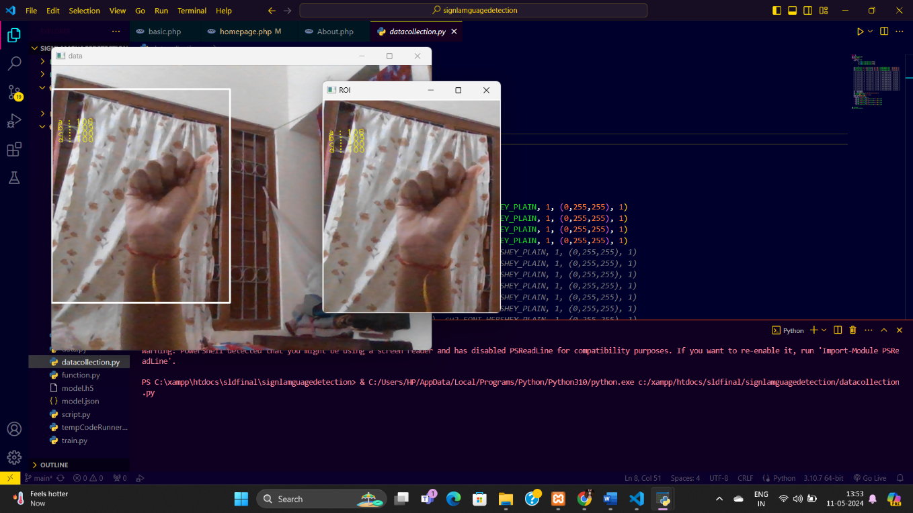

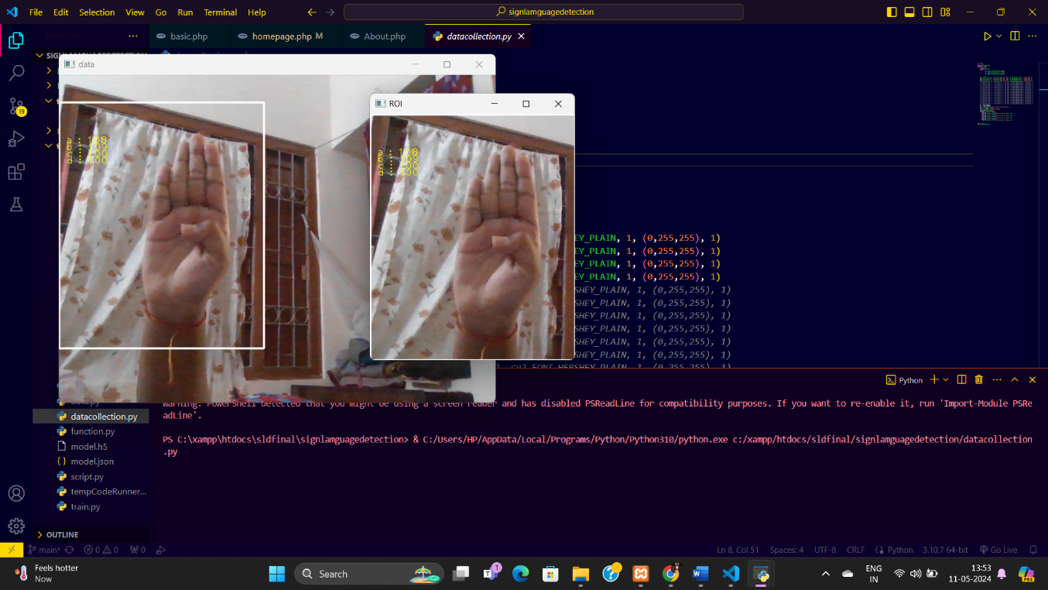

**5.3.2. Import and Connect Data:**

**Source Code:**

import cv2

import numpy as np

import os

import mediapipe as mp

mp_drawing = mp.solutions.drawing_utils

mp_drawing_styles = mp.solutions.drawing_styles

mp_hands = mp.solutions.hands

def mediapipe_detection(image, model):

    image = cv2.cvtColor(image, cv2.COLOR_BGR2RGB) *# COLOR CONVERSION BGR 2 RGB*

    image.flags.writeable = False                  *# Image is no longer writeable*

    results = model.process(image)                 *# Make prediction*

    image.flags.writeable = True                   *# Image is now writeable*

    image = cv2.cvtColor(image, cv2.COLOR_RGB2BGR) *# COLOR COVERSION RGB 2 BGR*

    return image, results

def draw_styled_landmarks(image, results):

    if results.multi_hand_landmarks:

      for hand_landmarks in results.multi_hand_landmarks:

        mp_drawing.draw_landmarks(

            image,

            hand_landmarks,

            mp_hands.HAND_CONNECTIONS,

            mp_drawing_styles.get_default_hand_landmarks_style(),

            mp_drawing_styles.get_default_hand_connections_style())

def extract_keypoints(results):

    if results.multi_hand_landmarks:

      for hand_landmarks in results.multi_hand_landmarks:

        rh = np.array([[res.x, res.y, res.z] for res in hand_landmarks.landmark]).flatten() if hand_landmarks else np.zeros(21*3)

        return(np.concatenate([rh]))

*# Path for exported data, numpy arrays*

DATA_PATH = os.path.join('MP_Data')

actions = np.array(['A','B','C','D'])

no_sequences = 30

sequence_length = 30

**5.3.3. Image recognition from Import:**

**Source Code:**

function import *

from time import sleep

for action in actions:

    for sequence in range(no_sequences):

        try:

            os.makedirs(os.path.join(DATA_PATH, action, str(sequence)))

        except:

            pass

*# cap = cv2.VideoCapture(0)*

*# Set mediapipe model*

with mp_hands.Hands(

    model_complexity=0,

    min_detection_confidence=0.5,

    min_tracking_confidence=0.5) as hands:

*# NEW LOOP*

*# Loop through actions*

    for action in actions:

*# Loop through sequences aka videos*

        for sequence in range(no_sequences):

*# Loop through video length aka sequence length*

            for frame_num in range(sequence_length):

*# Read feed*

*# ret, frame = cap.read()*

                frame=cv2.imread('Image/{}/{}.png'.format(action,sequence))

*# frame=cv2.imread('{}{}.png'.format(action,sequence))*

*# frame=cv2.cvtColor(frame,cv2.COLOR_BGR2GRAY)*

*# Make detections*

                image, results = mediapipe_detection(frame, hands)

*#                 print(results)*

*# Draw landmarks*

                draw_styled_landmarks(image, results)

*# NEW Apply wait logic*

                if frame_num == 0:

                    cv2.putText(image, 'STARTING COLLECTION', (120,200),

                               cv2.FONT_HERSHEY_SIMPLEX, 1, (0,255, 0), 4, cv2.LINE_AA)

                    cv2.putText(image, 'Collecting frames for {} Video Number {}'.format(action, sequence), (15,12),

                               cv2.FONT_HERSHEY_SIMPLEX, 0.5, (0, 0, 255), 1, cv2.LINE_AA)

*# Show to screen*

                    cv2.imshow('OpenCV Feed', image)

                    cv2.waitKey(200)

                else:

                    cv2.putText(image, 'Collecting frames for {} Video Number {}'.format(action, sequence), (15,12),

                               cv2.FONT_HERSHEY_SIMPLEX, 0.5, (0, 0, 255), 1, cv2.LINE_AA)

*# Show to screen*

                    cv2.imshow('OpenCV Feed', image)

*# NEW Export keypoints*

                keypoints = extract_keypoints(results)

                npy_path = os.path.join(DATA_PATH, action, str(sequence), str(frame_num))

                np.save(npy_path, keypoints)

*# Break gracefully*

                if cv2.waitKey(10) & 0xFF == ord('q'):

                    break

*# cap.release()*

    cv2.destroyAllWindows(from)

**Output:**

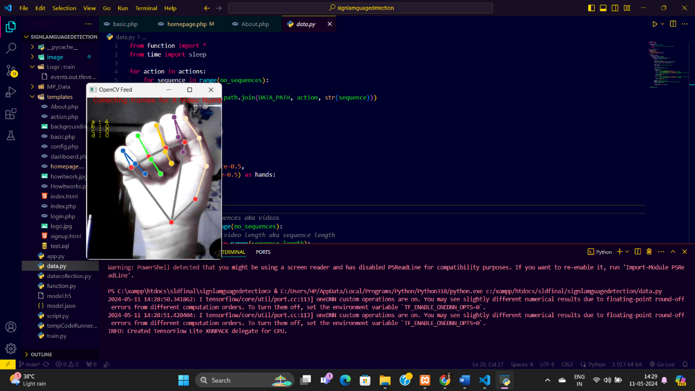

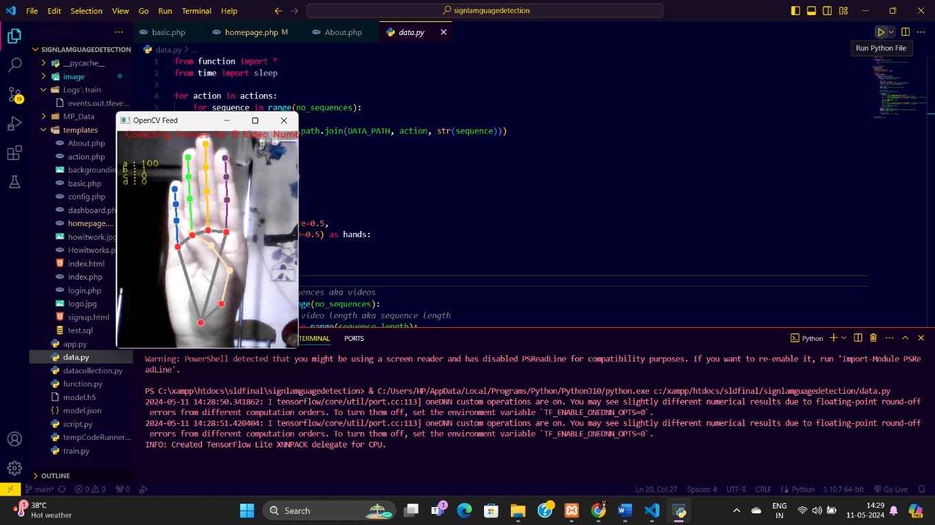

**5.3.4. Train Model:**

**Source Code:**

from function import *

from sklearn.model_selection import train_test_split

from keras.utils import to_categorical

from keras.models import Sequential

from keras.layers import LSTM, Dense

from keras.callbacks import TensorBoard

from keras.preprocessing.sequence import pad_sequences

label_map = {label:num for num, label in enumerate(actions)}

*# print(label_map)*

sequences, labels = [], []

for action in actions:

    for sequence in range(no_sequences):

        window = []

        for frame_num in range(sequence_length):

            res = np.load(os.path.join(DATA_PATH, action, str(sequence), "{}.npy".format(frame_num)),allow_pickle=True)

            window.append(res)

        sequences.append(window)

        labels.append(label_map[action])

*#padded_sequences = pad_sequences(sequences, maxlen=sequence_length, padding='post', truncating='post', dtype='float32')*

X = np.array(sequences)

y = to_categorical(labels).astype(int)

X_train, X_test, y_train, y_test = train_test_split(X, y, test_size=0.05)

log_dir = os.path.join('Logs')

tb_callback = TensorBoard(log_dir=log_dir)

model = Sequential()

model.add(LSTM(64, return_sequences=True, activation='relu', input_shape=(30,63)))

model.add(LSTM(128, return_sequences=True, activation='relu'))

model.add(LSTM(64, return_sequences=False, activation='relu'))

model.add(Dense(64, activation='relu'))

model.add(Dense(32, activation='relu'))

model.add(Dense(actions.shape[0], activation='softmax'))

res = [.7, 0.2, 0.1]

model.compile(optimizer='Adam', loss='categorical_crossentropy', metrics=['categorical_accuracy'])

model.fit(X_train, y_train, epochs=200, callbacks=[tb_callback])

model.summary()

model_json = model.to_json()

with open("model.json", "w") as json_file:

    json_file.write(model_json)

model.save('model.h5')

**Output:** It will automatically create two files.

1.model.json

2.model.h5

**5.3.5. Generate Output Screen:**

**Source Code:**

from function import *

from keras.utils import to_categorical

from keras.models import model_from_json

from keras.layers import LSTM, Dense

from keras.callbacks import TensorBoard

json_file = open("model.json", "r")

model_json = json_file.read()

json_file.close()

model = model_from_json(model_json)

model.load_weights("model.h5")

colors = []

for i in range(0,20):

    colors.append((245,117,16))

print(len(colors))

def prob_viz(res, actions, input_frame, colors,threshold):

    output_frame = input_frame.copy()

    for num, prob in enumerate(res):

        cv2.rectangle(output_frame, (0,60+num*40), (int(prob*100), 90+num*40), colors[num], -1)

        cv2.putText(output_frame, actions[num], (0, 85+num*40), cv2.FONT_HERSHEY_SIMPLEX, 1, (255,255,255), 2, cv2.LINE_AA)

    return output_frame

*# 1. New detection variables*

sequence = []

sentence = []

accuracy=[]

predictions = []

threshold = 0.8

cap = cv2.VideoCapture(0)

*# cap = cv2.VideoCapture("https://192.168.43.41:8080/video")*

*# Set mediapipe model*

with mp_hands.Hands(

    model_complexity=0,

    min_detection_confidence=0.5,

    min_tracking_confidence=0.5) as hands:

    while cap.isOpened():

*# Read feed*

        ret, frame = cap.read()

*# Make detections*

        cropframe=frame[40:400,0:300]

*# print(frame.shape)*

        frame=cv2.rectangle(frame,(0,40),(300,400),255,2)

*# frame=cv2.putText(frame,"Active Region",(75,25),cv2.FONT_HERSHEY_COMPLEX_SMALL,2,255,2)*

        image, results = mediapipe_detection(cropframe, hands)

*# print(results)*

*# Draw landmarks*

*# draw_styled_landmarks(image, results)*

*# 2. Prediction logic*

        keypoints = extract_keypoints(results)

        sequence.append(keypoints)

        sequence = sequence[-30:]

        try:

            if len(sequence) == 30:

                res = model.predict(np.expand_dims(sequence, axis=0))[0]

                print(actions[np.argmax(res)])

                predictions.append(np.argmax(res))

*#3. Viz logic*

                if np.unique(predictions[-10:])[0]==np.argmax(res):

                    if res[np.argmax(res)] > threshold:

                        if len(sentence) > 0:

                            if actions[np.argmax(res)] != sentence[-1]:

                                sentence.append(actions[np.argmax(res)])

                                accuracy.append(str(res[np.argmax(res)]*100))

                        else:

                            sentence.append(actions[np.argmax(res)])

                            accuracy.append(str(res[np.argmax(res)]*100))

                if len(sentence) > 1:

                    sentence = sentence[-1:]

                    accuracy=accuracy[-1:]

*# Viz probabilities*

*# frame = prob_viz(res, actions, frame, colors,threshold)*

        except Exception as e:

*# print(e)*

            pass

        cv2.rectangle(frame, (0,0), (300, 40), (245, 117, 16), -1)

        cv2.putText(frame,"Output: -"+' '.join(sentence)+''.join(accuracy), (3,30),

                       cv2.FONT_HERSHEY_SIMPLEX, 1, (255, 255, 255), 2, cv2.LINE_AA)

*# Show to screen*

        cv2.imshow('OpenCV Feed', frame)

*# Break gracefully*

        key = cv2.waitKey(1) & 0xFF

        if key == 27:

            break

    cap.release()

cv2.destroyAllWindows()

**Output:**

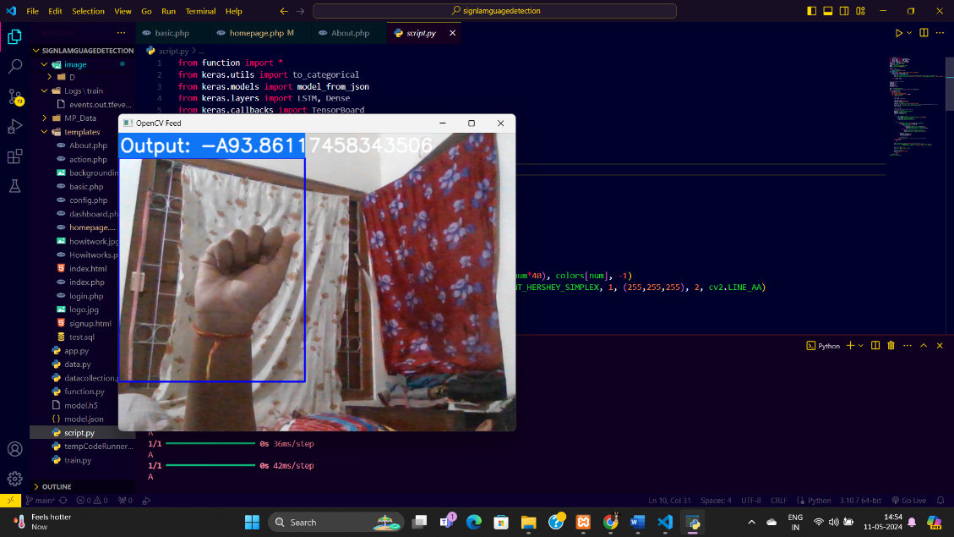

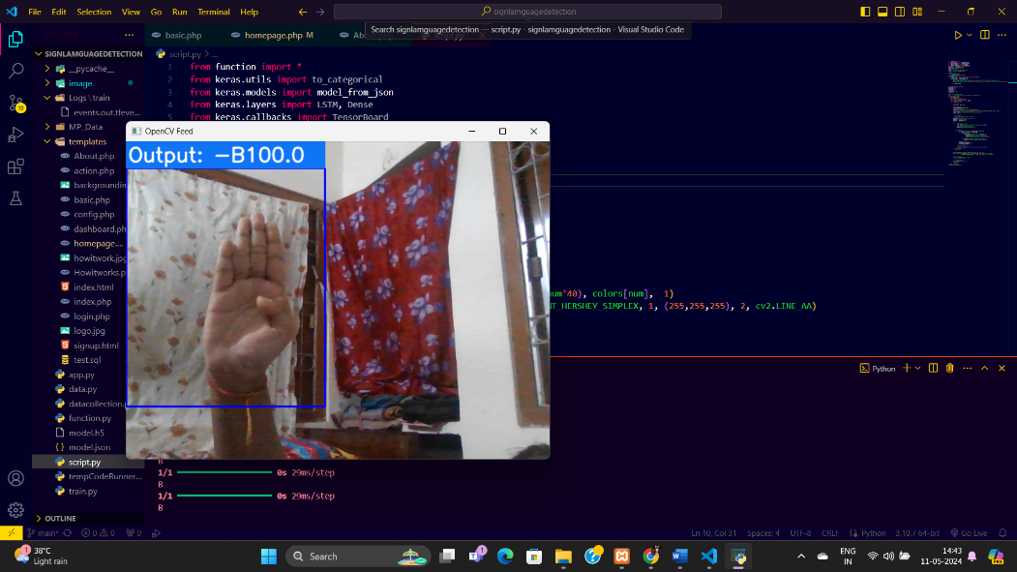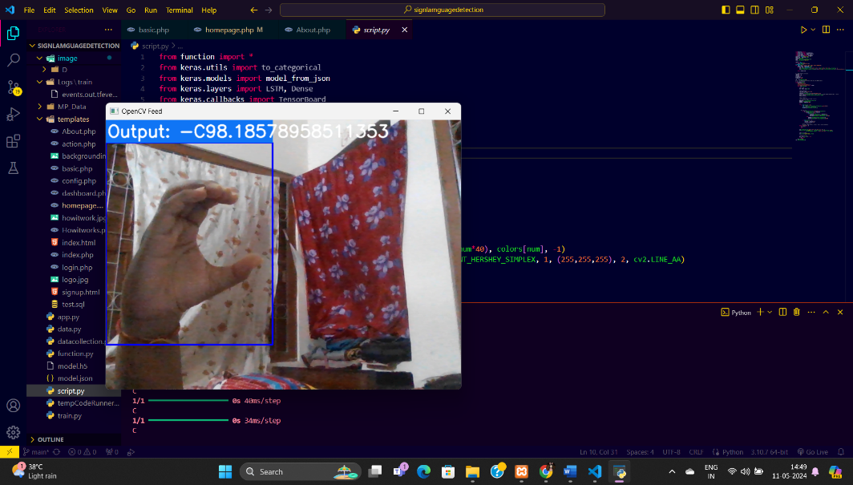

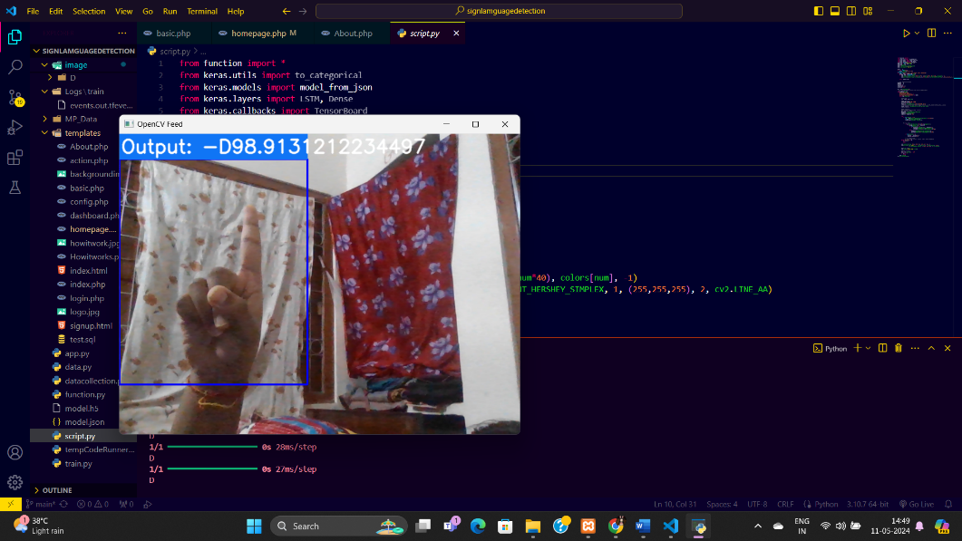

**5.3.6. Connect Front-end and Back-end:**

**Source Code:**

from flask import Flask, render_template, Response

import subprocess

import cv2

import numpy as np

app = Flask(__name__)

@app.route('/')

def index():

    return render_template('homepage.php')

@app.route('/run_script', methods=['GET'])

def run_script():

    subprocess.Popen(['python', 'script.py'])

    return 'Python script started.'

@app.route('/stop_script', methods=['GET'])

def stop_script():

*# Using 'taskkill' to kill the process by the name of the Python executable running 'script.py'*

    command = 'taskkill /f /im python.exe /t'

    subprocess.Popen(command, shell=True)

    return 'Python script stopped.'

if __name__ == "__main__":

    app.run(debug=True)

**CHAPTER-VI**

**Limitation and Future Scope**

* **The limitations of current sign language recognition systems primarily revolve around accuracy, adaptability, and accessibility. Here are some key points:**

**1. Accuracy:** While modern systems have improved significantly, they still face challenges in accurately interpreting complex or fast signing gestures. Variations in signing styles, regional differences, and non-standard gestures can affect accuracy.

**2. Adaptability:** Sign language is diverse, with different versions and dialects worldwide. Systems may struggle to adapt to new signs or variations not included in their training data, limiting their practicality in real-world scenarios.

**3. Accessibility:** Many existing systems rely on specialized hardware or expensive software, making them less accessible to individuals or communities with limited resources. Improving affordability and ease of use is crucial for widespread adoption.

**4. Real-time Processing:** Some systems may experience delays in processing and recognition, particularly in real-time applications such as live interpretation or interactive communication, which can hinder seamless interactions.

**5. Environmental Factors:** Background noise, lighting conditions, and distractions can impact the system's performance, leading to errors or misinterpretations.

* **Future scope for sign language recognition systems includes:**

**1. Improved Accuracy:** Advancements in machine learning algorithms, especially those based on deep learning, can enhance recognition accuracy by learning from larger and more diverse datasets.

**2. Adaptive Learning:** Systems that can continuously learn and update their recognition models based on user feedback and new sign language variations can improve adaptability and performance.

**3. Real-time Feedback:** Integrating real-time feedback mechanisms can help users correct misinterpretations quickly, improving communication effectiveness.

**4. Wearable Technology:** Integration with wearable devices like smart gloves or cameras can provide a more natural and accessible way for users to interact with sign language recognition systems.

**5. Accessibility and Affordability:** Developing low-cost, portable, and user-friendly systems can make sign language recognition technology more accessible to a wider range of users, including individuals in remote areas or with limited resources.

**6. Multimodal Integration:** Combining sign language recognition with other communication modalities like speech recognition or text-to-speech conversion can create more comprehensive communication tools for diverse user needs.

These advancements can contribute to the broader goal of promoting inclusivity, accessibility, and effective communication for individuals using sign language.

**CHAPTER-VII**

**Conclusions**

In conclusion, while sign language recognition systems have made significant progress, they still face challenges related to accuracy, adaptability, accessibility, real-time processing, and environmental factors. These limitations can impact their effectiveness in real-world applications, particularly in diverse and dynamic signing environments.

However, the future of sign language recognition systems holds promising opportunities for improvement and innovation. Advancements in machine learning algorithms, adaptive learning techniques, real-time feedback mechanisms, wearable technology integration, accessibility, and affordability can contribute to overcoming these limitations.

By focusing on improving accuracy, adaptability, and accessibility while considering real-time processing constraints and environmental factors, sign language recognition systems can evolve into more effective and inclusive communication tools for individuals who use sign language. This journey towards enhanced functionality and usability aligns with the broader goal of promoting inclusivity, accessibility, and effective communication for diverse user communities.

**CHAPTER-VIII**

**References and Bibliographies**

* <https://www.google.co.in/>
* <https://www.wikipedia.org/>
* <https://www.geeksforgeeks.org/>
* <https://www.youtube.com/>
* <https://github.com/harshbg/Sign-Language-Interpreter-using-Deep-Learning>
* <http://localhost/phpmyadmin/>
* <http://localhost/phpmyadmin/index.php?route=/sql&pos=0&db=slrsdb&table=admin>
* <http://localhost/sldfinal/signlamguagedetection/templates/homepage.php>